FH456-- How to setup Universal Repeater mode
Note: This article will guide you how to setup Universal Repeater mode and the steps as below.

Step 1: Connect your computer to the LAN port.Power on the FH456.
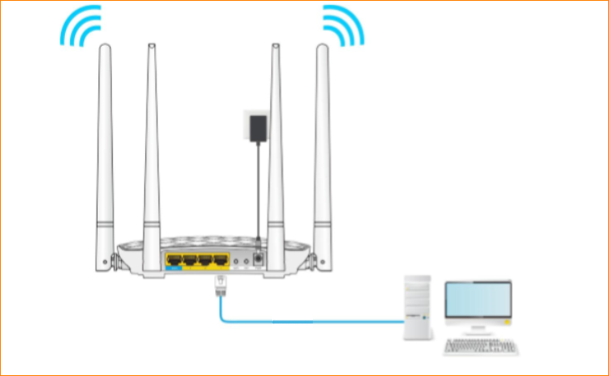
You can also use your smartphone to configure the router.
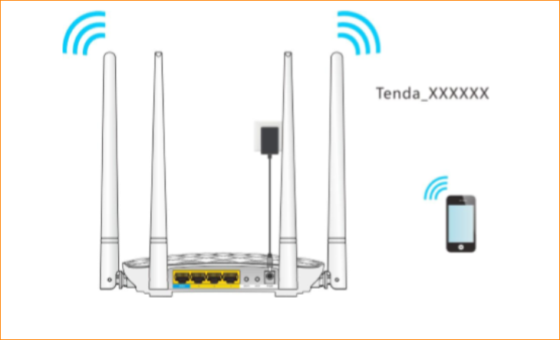
Step 2: Open a Web Browser -> Type http://tendawifi.com or 192.168.0.1 in the address bar -> Press Enter
Step 3: Go to “Wireless repeating”-> Click “Universal Repeater”
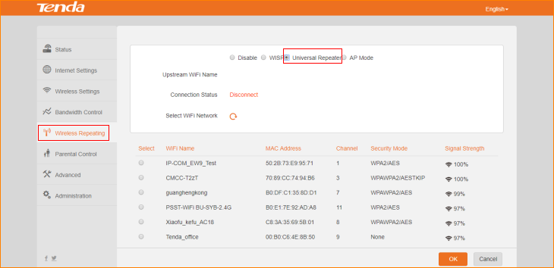
Step 4: Select “Upstream WiFi Name”, type password in “WiFi Password”, click “OK” to save all the settings.
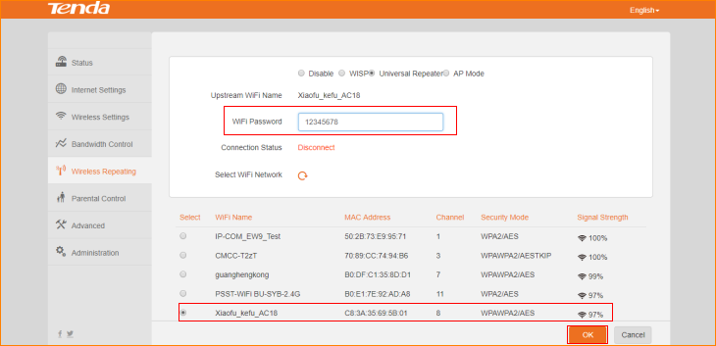
Note: For the convenience of management, when you setup Universal Repeater mode, we have to make sure this router IP address is different from upstream router IP address, but in the same network segment. Such as if the upstream router IP address is 192.168.2.1,we have to change this router IP address to 192.168.2.X, X∈(2-254).
After reboot, connect LAN1/LAN2/LAN3 port of router, or reconnect wireless signal of the router, try whether you can surf the internet.

